From July 16-18, 2016, 148 families and professionals from 32 states and 2 territories gathered in Austin, TX. Our goal was to gather family leaders from across the country to increase the quality of education and services for individuals who are deaf-blind, while serving as pioneers in their own communities. Our participant comments are in italics.
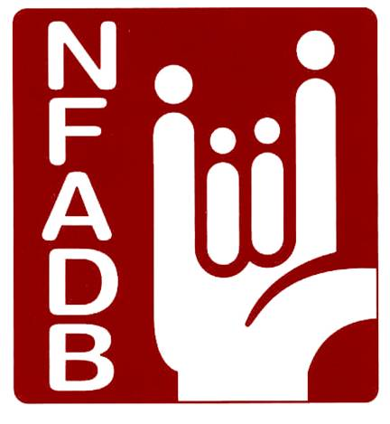
2 amazing partners…National Center on Deaf-Blindness and Texas Deaf-Blind Project
0 participants who did not go home filled with awe and inspiration! “Fabulous weekend!”
1 our fantastic presenters and support personnel were number one in inspiration and knowledge
6 state affiliates being formed, renewed and energized, “Feeling empowered”
S tate Deaf-Blind Project Family Engagement Coordinators attended and supported families
Y ou made a difference by donating your resources to our program
M any families met from each state and created Action Plans to take home and initiate
P lans are underway for families to reconnect via conference calls and Family to Family Connections
O verview of the Cogswell Macy Act and discussions regarding legislation is making a difference
S o many ideas being shared, topics of interest discussed for hours, “What I learned was invaluable.”
I ncredible Texas hospitality, laughs, tears, bonds created, friendships formed, fun at social activities, 35 new members, talented deaf-blind musicians entertained, deaf-blind artists created decorations and gifts, podcasts were recorded
U nderstanding ways to communicate our stories, collaborative decision making, creating partnerships, “The networking with other parents was priceless, I learned IEP lingo from other parents that has helped me advocate for my child.” “Great connections- great ideas.”
M any goals set: initiate action plans created with regional teams throughout the country, monthly podcasts, more information on the website, increased face book and social media presence, Spanish and English webinars, the Family to Family Connections program to join members with common interests via phone and/or video, empower current and new state affiliations, influence legislators to support the Cogswell-Macy Act, facilitate Intervener Modules, disseminate information quickly to membership and list serve regarding current issues and educational opportunities.

